Chacewater School LEAP Curriculum

Class: Reception | Curriculum Theme - Come Outside  Curriculum Driver – Understanding the World – The World (Science and Geography based) |  |  |  |  |  |  |  |  |  |  |  |  | Term: Spring Term 2
L – Visit the local community garden  Planting and potting seeds  outdoor adventures, looking at changes in different seasons |  |  | E – practical experiences of planting and potting, watching what happens over time  Experimenting with what happens with plants when you place them in different parts of the environment |  |  | A -  Taking care and looking after living things |  |  |  |  |  | P – Understand the key features of the plants. Understand what happens in different seasons of the year.
 |  | Sequence of Learning
Main coverage in afternoon sessions – UTW –The World and EAD. These are additional to our continuous revisit of our prime areas.

This term our hook books will be
The Hungry Caterpillar
Little Acorn
Jack and the Beanstalk
THe Enormous Turnip
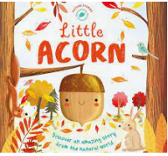
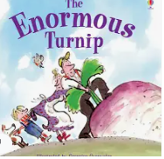
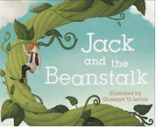
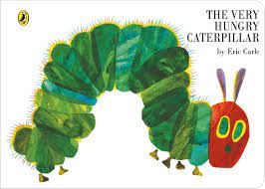

Sequence of lessons may differ from what has been put down as children’s interests at the time of teaching can often lead to the learning that takes place.

Subject | Intent and links to previous learning | 1 |  | 2 |  |  | 3 |  | 4 | 5 | 6 |  | 7 |  | Outcome/Composite
Key objective - Understand the key features of the life cycle of a plant and an animal.

Plant seeds and care for growing plants. Understand the key features of the life cycle of a plant and an animal. Begin to understand the need to respect and care for the natural environment and all living things.
Understand the effect of changing seasons on the natural world around them.

Examples of how we do this-
Plant seeds and bulbs so children observe growth and decay over time
Plan and introduce new vocabulary related to the exploration. Encourage children to use it in their discussions, as they care for living things.
Guide children’s understanding by drawing children’s attention to the weather and seasonal features.

Understanding the world: The World (Science) focus | Understand the lifecycle of frogs – butterflies  Understand the key features of the plants. Understand what happens in different seasons of the year. | Observe lifecycles of frogs and butterflies.  Observe the lifecycle of a human – baby to adult/old person.  Healthy foods/ unhealthy foods.  Hook Book - The Hungry Caterpillar |  |  | Looking at different parts of a plant.  What do plants need to grow?  Experimenting with different environments for plants.  Hook Book- Jack and the Beanstalk |  | Planting beans and watching them grow.  Looking at different vegetables.  Making a soup with the  vegetables for the children to taste.  Hook Book- The Enormous Turnip |  |  | Seasons- what happens during the seasons, look at the changes.  Outdoor Adventures- What can you see, smell, touch, hear?  Hook Book- Little Acorn |  |  |  |  | Understand the key features of the plants. Understand what happens in different seasons of the year.
Expressive Arts and Design: Creating with Materials (Art focus) | Mixing colours for purpose – Art focus.  Create a painting from the artist – Charles Voysey – Let us pray. | Explore colour and colour-mixing for purpose – talk about these.  What is happening and why?  What other colours could we make? |  |  |  |  |  | 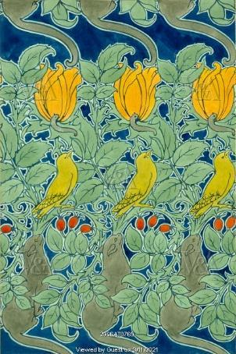  Create a painting from the artist – Charles Voysey – Let us pray inspired by our current animal work. |  |  |  |  |  | Mixing colours for purpose – Art focus.  Create a painting from the artist – Charles Voysey – Let us pray.
Expressive Arts and Design: Creating with Materials (DT focus – collage). | Exploring parts of a plant/flower by creating them using junk modelling and building materials. | Explore different materials freely, to develop their ideas about how to use them and what to make.  Develop their own ideas and then decide which materials to use to express them. Join different materials and explore different textures.  Create collaboratively, sharing ideas, resources and skills. |  |  |  |  |  |  |  |  |  |  |  | Exploring parts of a plant/flower by creating them using junk modelling and building materials.
Expressive Arts and Design: Being Imaginative |  | From our role play area and imaginarium we hope that children in the Acorns class will:  Develop storylines in their pretend play – linked to what they have learnt through the hook books or by taking on a role in their play to someone or something familiar to them. Dressing up costumes are used in the role play to inspire children with this.  Return to and build on their previous learning, refining ideas and developing their ability to represent them. – Linked to the hook book work we are doing and how we develop learning about those in the community. Opportunities for the children to dress up as ambulance, fire, police people etc.  Create collaboratively, sharing ideas, resources and skills – working together. Adults modelling how we play nicely, share ideas, take in turns etc.
Music |  | Through various opportunities in the school day, children in the Acorns class will:  Remember and sing entire songs.  Sing the pitch of a tone sung by another person (‘pitch match’).  Create their own songs or improvise a song around one they know.  Listen attentively, move to and talk about music, expressing their feelings and responses.  Music CPD to run with children every Wednesday
Communication and Language | During the class day and inside and outside provisions, the children in the Acorns class will:  Understand a question or instruction that has two parts – this is modelled by an adult daily  Learn new vocabulary through the various learning opportunities that take part in class daily.  Ask questions to find out more and to check they understand what has been said to them – opportunities for use of tapestry for children to ask and answer questions independently.  Articulate their ideas and thoughts in well-formed sentences – modelled by the teaching staff.  Listen to and talk about stories to build familiarity and understanding – regular opportunities to listen to stories, to talk about them, to engage in them, act them out, use of our story stage etc.
RE | F1 GOD/ CREATION: Why is the word ‘God’ so important to Christians? | Ø talk about what is precious to them;  Ø begin to explain why something is precious to them;  Ø understand that Christians believe we are precious to God.  Bring a box / tapestry of things that are precious to them/ why they are precious to them. |  |  |  |  | Ø be familiar with the Christian story of creation as found in The Bible;  Ø know that Christians believe God made the world. |  |  | ]  Ø think about how we should look after and treat the natural world.  (Focus in outdoor adventure) |  |  |  |  | F1 GOD/ CREATION: Why is the word ‘God’ so important to Christians?
Personal, Social and Emotional Development | During the class day and inside and outside provisions, the children in the Acorns class will:  Build constructive and respectful relationships.  Express their feelings and consider the feelings of others.  Show resilience and perseverance in the face of challenge.  Know and talk about the different factors that support their overall health and wellbeing: • regular physical activity • healthy eating – linked to the hook book ‘Supertato’ through outdoor adventure and continuous. What is a vegetable? What is a fruit? How do we know? Supertato hook book link.
Physical Development - Gross and Fine motor. | During the class day and inside and outside provisions, the children in the Acorns class will:  Develop their small motor skills so that they can use a range of tools competently, safely and confidently. Suggested tools: pencils for drawing and writing, paintbrushes, scissors, knives, forks and spoons.  Further develop the skills they need to manage the school day successfully: • lining up and queuing • mealtimes  Use one-handed tools and equipment, for example, making snips in paper with scissors. Use a comfortable grip with good control when holding pens and pencils.  Be increasingly independent as they get dressed and undressed, for example, putting coats on and doing up zips – PE and through changing for outdoor adventure.
Reading Opportunities |  | RWI is constructed accordingly:

