Chacewater School

Relationship Policy
(including Positive Behaviour Policy) 2021
Ratified Date:1.2.23
Review Date:1.2.24

Positive behaviour developed through positive relationships

Our ethos is driven by the idea of ‘caring and learning together’ and this policy outlines the framework that we use to make this happen with regard to behaviour and relationships. Everyone in our school has a collective responsibility to make sure that Chacewater School provides a safe and effective learning environment.
Chacewater School has four key behaviour values which act as our school rules:

These values are used to promote positive behaviour and learning by encouraging and developing positive relationships. Each ‘rule’ helps all members of our community to develop respect and responsibility, whilst setting appropriate boundaries. Through this approach and other learning strategies we endeavour to support all members of our community in and out of Chacewater School. We believe that this approach is key to positive teaching and learning experiences. Staff will model these rules through all interactions at school and these values are regularly unpicked with the children. It is our expectation that all children know these and can refer to them without hesitation. We have unpicked each of these further, with staff and children, and they can be seen in Appendix 2.
Our approach is committed to safeguarding and promoting positive emotional and physical health and well-being of every individual involved in our school community.
At Chacewater all members of our team share a commitment to establishing and maintaining positive relationships between:
- Parent and child
- Child and child
- Child and school staff
- Parent and school staff
- School staff and senior leaders
- School staff and external agencies
Due to our school’s thorough understanding of how to promote positive learning experiences, we have a wealth of individual and group strategies to achieve this. We apply Trauma Informed and Restorative approaches as well as learning strategies designed to promote reflection (thinking about behaviours/actions and their consequences) and respect.
We expect all staff to ensure that they are:
- warm and approachable
- clear when communicating and offer appropriate instructions
- authentic
- clear and consistent with boundaries
- consistent
- empowering learners
- reliable

At Chacewater School, all behaviour is understood as communication and poor behaviour is understood to result from an unmet need or as an adapted, defensive, stress response. The understanding that children learn best within positive, trusting relationships informs our approach to managing and then to adapting behaviour. We expect staff to work to identify the need and provide developmentally appropriate support to remove the barriers to successful engagement in school life.
Chacewater School welcomes the interest and close involvement of parents/carers and by choosing to send their child to our school, we expect that parents/carers will support the school’s behaviour policy. If a child’s behaviour gives particular cause for concern, parents/carers will be involved as soon as possible. Parents/carers will be invited to work with the School in order to support the child to develop appropriate behaviour.

Specific approaches/strategies
TIER 1 - MAKING IT WORK
At Chacewater School we strongly believe that all children can succeed and we have a commitment to use all our knowledge to ensure that children feel safe, supported and are given the opportunity to follow our behaviour values and provide an atmosphere conducive to learning. Inclusive classroom strategies used to ‘make it work’ are key to ensure positive engagement and recognise that at times children could find some areas of school difficult and may need additional support from adults or their peers. Children need routines in place to feel safe and secure. With routines and expectations in place, children are in a safe place to manage their feelings, emotions and behaviour. It will foster opportunities for children to learn and remove many barriers to learning.
These strategies are:
- Use of visual timetables
- Use of positive affirmations to ‘catch’ children following the school values and celebrate
- Weekly ‘Golden Awards’ to celebrate children who have displayed the school values.
- House points and HT rewards to celebrate and recognise good choices
- High expectations of good manners from adults and children alike.
- Use of the language of ‘I wonder…’ to help children articulate why they may be displaying adverse behaviours or emotions.

- Use of ‘learning powers’ vocabulary and anecdotes to support children in showing resilience, resourcefulness, reflection and reciprocity to support their learning and relationships. Linked to the school behaviour value of ‘be brilliant’.
They may also include (dependent on individual need):
- Use of traffic light cues to signal transitional moments
- Specifically modified visual timetables for children who may need simplified or additional support, including now and next boards.
- Use of ‘I wonder…’ boards to further help children articulate why they may be displaying adverse behaviours or emotions.
- Use of a 5 point scale to help children recognise how they are feeling and how they can deescalate themselves.

---------------------------------------------------------------------------------------------------
Staff understand that behavioural strategies will not work if the behaviour is due to an unmet need. Behavioural strategies for dysregulation can paradoxically make things worse.
All staff at Chacewater School understand the importance of genuine praise and understand that this is presented to the children in a variety of ways. Choice of language is crucial when dealing with behaviour – Appendix 1. We have a clear system of ‘rewards’ which include:
- Continue reference to our values - Appendix 2 and Appendix 3.
- Genuine recognition and praise.
- House Points to promote a sense of belonging and feeling part of a school-wide House Team
- ‘Brilliant Tokens’ which are given and collected to earn a class reward and then in turn contribute to a whole school reward (when our Oak tree is completed). Appendix 4
- Headteacher Awards
- Display and sharing of learning and work
- Being given additional responsibilities
- Sharing successes with parents/carers
- Celebration in assembly
- Golden Awards - shared weekly in assembly

Any poor behaviour choice is dealt with following the process below.
TIER 2
This system will only be successful if the staff members have addressed their learning, sensory and emotional needs in ‘Tier 1 - making it work’.
There are times when children may choose to distract other children from their learning and not follow our ‘behaviour values’. When this happens, a clear system is in place. Staff are aware that these times are rare and will be mindful that the distraction could be a result of unidentified trauma or difficulty which may be triggered. When speaking to the child, the adult is mindful of this and is clear in describing the desired behaviours.
Whilst the behaviour may not be following our rules, staff will still try to understand the behaviour and question any unmet needs, or relationship difficulties within the classroom. Once this is addressed, the behaviour should improve.
If the child is dysregulated and is unable to make appropriate choices, reference to the 5 point scale is used and the child is supported in this. For further detail see the rest of this policy.
Staff are clear as they can be, given the information held about the child and the context of the behaviours, to the behaviour being a choice, not a result of finding the learning challenging, or an emotional or sensory dysregulation.
It will be made clear to the child what the undesired behaviour/choice is and a reminder of the behaviour wanted will be given, if appropriate highlighting positive examples that are already happening within the class, playground etc.

TIER 3
If the child chooses to continue the same inappropriate behaviour and not working within our behaviour values then the child will be given a verbal warning. It is important that this is not done publicly but that the child is clear that they have received a warning and why they have received this. If it is needed, then the member of staff will talk to the child, again making it clear what the behaviour is how they can change it/make a better choice.
TIER 4:
If the child still continues with the same inappropriate/unwanted behaviour that are not within the behaviour values then the child will be given a second warning. The steps outlined in ‘tier 3’ should again be followed at this point.
If continued unwanted behaviour continues after this point then the child’s name will be added to ‘reflective fox’ book. If necessary at this point then a member of SLT will be contacted and the child will be taken to a different room to have ‘time out’ and an opportunity to reset.
The ‘reflective fox’ book is used to help children have time to consider what adverse behaviours they’ve displayed and how they might restore their own sense of well-being and repair relationships with peers and adults. When there name is added to this book then the child spends time with an adult to reflect and think through behaviour and choices- this can be during a break / end of session and will be dependent on the child and specific needs.
The incident is written up on CPOMS and the phase leader and Headteacher is copied in.
If there are several incidents in a short period of time then the main care-giver will be informed by the class teacher. Where there is a pattern or persistent poor behaviour then a more formal meeting will be held.
There may be times where staff need support after incidents, and support is identified as a team. Time is taken to unpick the incident and supervision is provided for staff involved.
------------------------------------------------------------------------------------------------
CPOMS is a tool to record any safeguarding concerns, as well as behaviour incidents. Entries on CPOMS are written as professionals, referring to staff as Mr/Ms … . The entries will provide factual information of the incident.
A: Antecedent - what was happening before
B: Behaviour - what behaviour we saw
C: Consequence - what happens immediately after the behaviour.
------------------------------------------------------------------------------------------------
At the end of the session or day, the adult ensures that the relationship is reestablished and the child knows not only what the desired behaviours should be, but also that the adult cares about them and believes that they can succeed. Conversations with children are always led showing kindness and compassion. They must be a “connection to get correction”

Playtimes & lunchtimes

The playtimes are appropriately staffed to ensure that all children are safe. Adults regularly enforce the Chacewater’s ‘behaviour values’, especially in relation to looking after equipment and treating people with kindness and respect - being gentle and thoughtful during play.

Adults on duty must:

- ensure all children are safe
- demonstrate their recognition of positive play and relationships
- encourage and teach children new games
- pre-empt any overly physical play and intervene
- be spaced out around the playground and their focus is on the wellbeing of the children.
- be aware of vulnerable children
- Have radios outside and radio for support instead of escalating any inappropriate behaviour.
- wear hi-vis vests so they are quickly identifiable by both the children and members of staff.

It is expected that members of staff on duty will be proactive and intervene to prevent the majority of friendship disputes and overly physical play from happening.
All adults are able to use key phrases when resolving differences in friendships:
- What happened?
- What were you thinking?
- How were you feeling?
- Who has been affected?
- What is needed to make things better?
- How can we move forward?

All efforts should be made to ‘make it work’ at playtimes; however, children come into meet with a member of the Senior Leadership team if:
· there is a serious physical assault on another child
· a child is being verbally abusive or rude (to staff or other children)
· there is a friendship dispute which needs unpicking in depth due to historic events or parental contact
- harmful sexual behaviour / racial or homophohic incident
It is important that the children check in with their class teacher at the start of the afternoon learning session, with a quick summary if an incident has taken place. They will let the classteacher know which adult has supported them in resolving the issue. If the lunchtime supervisor is leaving after lunch, it is crucial that any vital information is passed onto class teacher or SLT before leaving the building. The class teacher must ensure that any significant incidents are recorded on CPOMS, and SLT copied in.
The 5 point scale
The 5 point scale is another strategy used when needed within the school to help and encourage children to recognise how they can change their behaviour.
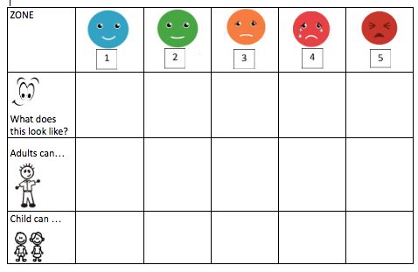

The 5 point scale is used across the school to support (as needed dependent on individual need) in regulating their behaviour. It is used to identify and recognise behaviours and the sensations to go with their behaviour, as well as making explicit what actions can be taken by the child and by adults to be calm and regulated. Outside on both playgrounds there are visual representatives of the 5 point scale to support the children in understanding how to regulate their emotions, and adults are able to use visual images to support them.
The Colour Monster
Particularly with our younger children, we use the ‘Colour Monster’ stories and images, alongside ‘Fill My Bucket’ stories. Reading these stories regularly to the younger children in school reinforces the vocabulary needed to articulate and understand the emotions being felt. An emphasis on our emotions being valid and normal but how we deal with them needs reflection and thought. ‘Fill My Bucket’ promotes empathy and tolerance as well as embedding the notion that our own actions impact on others. The emphasis with younger children is labelling their emotion out loud, for example: ‘I can see you’re angry because your fists are clenched and your face is screwed up’... ‘I can see that you’re unhappy because you’re crying and your head is down.’ ‘I’m feeling so loved because you’re all looking at me when I’m talking.’
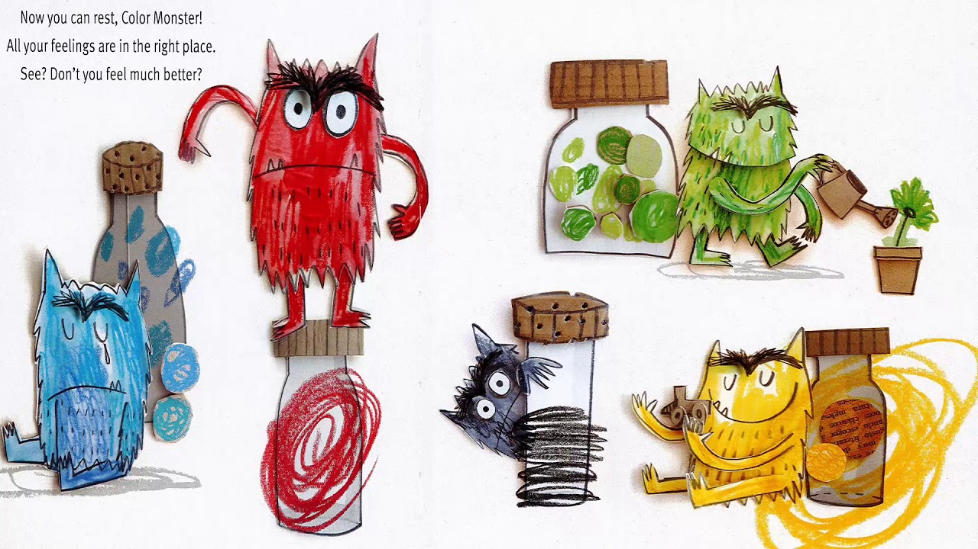

The Chacewater approach is committed to educational practices which Protect, Regulate, Relate and Reflect.
----------------------------------------------------------------------------------------------------
Our school is committed to educational practices which Protect, Relate, Regulate and Reflect;

Protect

- Increased ‘safety cues’ in all aspects of the school day; ‘meet and greet’ at the classroom door and an open door policy for informal discussions with parents/ carers.
- Staff trained in ‘PACE’ modes of interaction (Hughes 2015); being warm emphatic, playful and curious (proven to shift children out of flight/fright/freeze positions).
- Staff ensure that interactions with children are socially engaging and not socially defensive, to decrease likelihood of children relating defensively (flight/fright/freeze).
- A whole school commitment to cease all use of harsh voices, shouting, put downs, criticism and shaming (proven to be damaging psychologically and neurologically).
- Staff ‘interactively repair’ occasions when they themselves move into defensiveness.
- Pedagogic interventions that help staff to get to know children better on an individual basis e.g. ‘I wish my teacher knew’. (What matters to them, who matters to them, their dreams, hopes). This is key to enabling children to feel safe enough to talk, if they wish, about painful life experiences, which are interfering with their ability to learn and their quality of life.
- Vulnerable children have easy and daily access to at least one named, emotionally available adult, and know when and where to find that adult. If the child does not wish to connect with the allocated adult, an alternative adult is found.
- School staff adjust expectations around vulnerable children to correspond with their developmental capabilities and experience of traumatic stress. This includes removing vulnerable and traumatised children in a kind and non-judgmental way from situations they are not managing well (e.g. children who are continually triggered into alarm states in the main playground can access a calmer, smaller areas with emotionally regulating adults).
- Provision of a clear, confidential and non-shaming system of self-referral for children’s help/talk time. The nurturing of staff in such a way that they feel truly valued and emotionally-regulated and in so doing to support them to interact throughout the school day with positive social engagement rather than defensiveness.

Relate

- A whole-school commitment to enabling children to see themselves, their relationships and the world positively, rather than through a lens of threat, danger or self-blame.
- Vulnerable children provided with repeated relational opportunities (with emotionally available adults) to make the shift from ‘blocked trust’ (not feeling psychologically safe with anyone) to trust, and from self-help to ‘help seeking’.

Regulate

- Relational interventions specifically designed to bring down stress hormone levels (e.g. from toxic to tolerable) in vulnerable children, enabling them to feel calm, soothed and safe. This is to support learning, quality of life and protect against stress-induced physical and mental illness, now and in later life.
- Evidence-based interventions that aim to repair psychological damage and brain damage caused by traumatic life experiences, through emotionally regulating, playful, enriched adult-child interactions. ∙ The emotional well-being and regulating of staff is treated as a priority to prevent burnout, stress related absence, or leaving the profession through stress-related illness, secondary trauma and/or feeling undervalued, blamed or shamed.

Reflect

- Staff training and development and training in the art of good listening, dialogue, empathy and understanding (instead of asking a series of questions/ giving lectures).
- Provision of skills and resources to support parents and staff in meaningful and empathetic conversations with vulnerable children who want to talk about their lives. This is to empower children to better manage their home situations and life in general.
- Within the context of an established and trusted relationship with a member of staff (working alliance), children are given the means and opportunity to symbolise painful life experiences through images as well as words, as a key part of ‘working through’ these experiences and memory re-consolidation. Means include the provision of different modes of expression, e.g. art/play/drama/ music/sand/emotion worksheets/emotion cards.
- PSHE (Personal, Social and Health Education) and psycho education as preventative input, informed by current research psychological and neuroscience) on mental health, mental ill health (full range of specific conditions), relationships (including parenting) emotions, social media and tools for how to ‘do life well’. Curricular content enables children to make informed choices about how they relate to others, how they live their lives, and how they treat their brains, bodies and minds.
- Staff development and training to help children move from ‘behaving’ their trauma/painful life experiences, to reflecting on those experiences, to reflecting on those experiences. Staff learn to do this through empathetic conversation, addressing children’s negative self referencing and helping them develop positive, coherent narratives about their lives.
- A behaviour policy based not on punishment and sanctions, but on resolution and interactive repair

TIER 5 - A HIGH LEVEL OF CONCERN

For children who find emotional regulation challenging and have persistent difficulties, a bespoke programme to support the child will be put in place in conjunction with the family, and external professionals when appropriate. This is a behaviour plan, which is under review half termly.
There should be ‘no surprises’ as parents/carers are informed when children are struggling in school.
‘Good discipline in schools is essential to ensure that all pupils can benefit from the opportunities provided by education. The Government supports head teachers in using exclusion as a sanction where it is warranted.’ (DfE ‘Exclusion from maintained schools, Academies and pupil referral units in England 2012)

All decisions to exclude are serious and only taken as a last resort or where the breach of the School rules is persistent or serious.

If the severity or frequency of incidents is not reduced by the above approaches or if an incident is considered severe enough then, following statutory guidelines, an external fixed term exclusion will be considered. This will be put in place to seek further support for the child, the parents/carers and the Trust in managing the child’s behaviour in the future. It is the School’s intention that any fixed term exclusions will be of the shortest time deemed possible, in order to seek support and put further measures in place.

Continued fixed term exclusions may lead to a reduced timetable for the child if it is the School’s belief that a reduced timetable would have a positive impact on the child's behaviour, prior to returning to school full-time as soon as possible. This will be discussed and agreed with the parents/carers prior to its instigation and reported to the local authority. A clear review date will be identified, and increased attendance will always be sought during these reviews.

Ongoing severe incidents and fixed term exclusions may lead the School to work with parents/carers to seek a managed move to another primary setting. This may include seeking alternative provision and is an option which would prevent a child being permanently excluded.

For the most serious behaviour incidents or in a situation where all other avenues of management have failed, a permanent exclusion will be instigated. This will be conducted within the statutory guidance and will be the decision of the Headteacher following consultation with the Chair of Governors. On occasion, the incident or occurrence may require immediate internal or external exclusion.

The following is a list of DfE examples where this may be required:
- Persistent, serious or offensive verbal or physical abuse of a child or adult
- Dangerous behaviour (likely to result in serious harm or accident)
- Deliberate damage to property
- Open defiance
- Leaving the school site without permission
- Bringing an illegal or dangerous substance or object into school.

Please note that we will always make reasonable adjustments for all pupils with SEND to fully-support them in meeting our behaviour expectations

It is important to note that the response or sanction given for any incident does not set a precedent for future responses to similar incidents of behaviour involving other children. The Headteacher will liaise with the Trust for support and advice regarding any points discussed in this policy.

REDUCED TIMETABLE
A reduced timetable should be an exceptional measure and can be arranged with the parent/carer arrangement through discussion with relevant professionals . The reasons may include:
- Medical reasons - where a pupil has a serious medical condition where recovery is the priority outcome.
- As part of a short-term support package where a pupil is struggling in the school setting, perhaps with behaviour.
- As part of a planned reintegration into school following an extended absence following, for example, exclusion, non-attendance or school refusal.
Schools needs to:
- seek parent/carer agreement before a child attends on a reduced timetable.
- review the arrangement regularly - at least every six weeks.
- involve parent/carer in their regular reviews of the arrangement and seek their agreement at each stage.
- report the arrangement to Cornwall Council as soon as it is set up and send updates each time the arrangement is reviewed.
If the child has an Education, Health and Care Plan any consideration of a reduced timetable must include the Local Authority. Further information and advice is available by contacting the Statutory SEN Service (contact details below) or by having a look at the Local Offer

----------------------------------------------------------------------------------------------------

USE OF REASONABLE FORCE
(DFE GUIDANCE July 2013 Use of reasonable force)
Schools can use reasonable force to:
· Remove disruptive children from the classroom where they have refused to follow an instruction to do so.
· Prevent a pupil behaving in a way that disrupts a school event or a school trip or visit.
· Prevent a pupil leaving the classroom where allowing the pupil to leave would risk their own safety or lead to behaviour that disrupts the behaviour of others.
· Prevent a pupil from attacking a member of staff or another pupil, or to stop a fight on the playground.
· Restrain a pupil at risk of harming themselves through physical outbursts.

In addition, Headteachers and authorised staff can use such force as is reasonable given the circumstances to conduct a search for the following prohibited items: knives and weapons; alcohol; illegal drugs; stolen items; tobacco and cigarette papers; fireworks; pornographic images and any article that has been or is likely to be used to commit an offence, cause a personal injury or damage a property. Force cannot be used to search for items banned under school rules.
No more force will be used than is reasonably necessary in the circumstances; acknowledging our legal duty to make reasonable adjustments for disabled children and children with special educational needs or disability (SEND).

----------------------------------------------------------------------------------------------------
SUSEPNSIONS/EXCLUSIONS
As a last resort, suspension or exclusion procedures will be enforced by the Headteacher and in line with the trust Exclsuion Poliy. Local guidelines will be closely followed. A MARU referral may also be considered as is likely that there is more happening for that child than we may know.
National Standard List of Reasons for Exclusion:
This list is providing descriptors of reasons for exclusions, the main reason for exclusion should be used on the electronic reporting form. The 12 categories should cover the main reasons for exclusions and the 'other' category should be used sparingly. The further detail suggesting what the descriptors cover should be used as a guide and this list is not intended to be used as a tick list for exclusions.
Physical assault against pupil
Includes:
- fighting
- violent behaviour
- wounding
- obstruction and jostling
Physical assault against adult
Includes:
- violent behaviour
- wounding
- obstruction and jostling
Verbal abuse / threatening behaviour against pupil
Includes:
- threatened violence
- aggressive behaviour
- swearing
- homophobic abuse and harassment
- verbal intimidation
- carrying an offensive weapon
Verbal abuse / threatening behaviour against adult
Includes:
- threatened violence
- aggressive behaviour
- swearing
- homophobic abuse and harassment
- verbal intimidation
- carrying an offensive weapon
Bullying
Includes:
- verbal
- physical
- homophobic bullying
- racist bullying
Racist abuse
Includes:
- racist taunting and harassment
- derogatory racist statements
- swearing that can be attributed to racist characteristics
- racist bullying
- racist graffiti
Sexual misconduct
Includes:
- sexual abuse
- sexual assault
- sexual harassment
- lewd behaviour
- sexual bullying
- sexual graffiti
Drug and alcohol related
Includes:
- possession of illegal drugs
- inappropriate use of prescribed drugs
- drug dealing
- smoking
- alcohol abuse
- substance abuse
Damage
Includes damage to school or personal property belonging to any member of the school community:
- vandalism
- arson
- graffiti
Theft
Includes:
- stealing school property
- stealing personal property (pupil or adult)
- stealing from local shops on a school outing
- selling and dealing in stolen property
Persistent disruptive behaviour
Includes:
- challenging behaviour
- disobedience
- persistent violation of school rules
Other
Includes incidents which are not covered by the categories above but this category should be used sparingly.

David Hick Jan ‘23
____________________________________________ Dated _______________
Author

David Hick Jan’23
_____________________________________________ Dated _______________
Headteacher
Polly Langford Jan ‘23

_____________________________________________ Dated _______________
Chairperson of Governing Body

Ratified at Full Governing Body Meeting: 1.2.23

Date of next review: 1.2.24

APPENDIX 1 – Choice of language

Negative phrasing – We don’t Want | Positive phrasing – We Do Want
Stop being silly!  Don’t throw those scissors  Stop running!  Don’t talk to me like that!  Calm down!  __________, please. | Stay still and listen.  Put the scissors down.  Remember to walk  Remember to speak calmly and respectfully  Come and join us for a story
No choice / open choice | Limited choice
Get here now!  Stop shouting now!  What do you want to do?  Would you like to join us for a story?  Shall we … ?  You must eat everything on your plate! | Come to this chair or sit in your carpet place.  Come and quietly tell me what you are worried about, or sit down with the class.  Do you want to do XX and YY?  Would you like to sit on the chair or the bean bag for the story?  Let’s do …?  Now you need to eat the peas or the potatoes.
Empowering the behaviour | Disempowering the behaviour
Come out from under that table  Come back here, now!  You are not allowed in there on your own!  Finish that work, now! | You can listen to the story from there.  I’ll catch up with you in 5 minutes.  I’ll come in with you.  In 5 minutes I’ll check you have completed XX amount.
Punishments | Sanctions / consequences
You are losing all your breaks all week!  Names on board/somewhere public | You know the consequences, you will miss lunchtime tomorrow.  I will talk to you about this, on your own, after the lesson.

APPENDIX 2 – Our School Behaviour Values

Value | What does it look like?
- Making others smile
- Showing understanding and empathy
- Looking out for others e.g. including people in our games
- Sharing
- Listening
- Choosing our words carefully
- Supporting our local community by ‘giving something back’
- ‘Own our mistakes’ - accept that there may be bumps along the way
- Don’t be afraid to tell the truth even if difficult
- Integrity – be true to yourself
- Lead by example
- Reflect on your mistakes and learn from these
- Be true to yourself
- Value other people’s differences and beliefs
- Treat others how you would wish to be treated
- Look after our things and the school environment
- Listen and follow instructions
- Show good manners and be polite

- Use our learning powers: reciprocal, resilient, resourceful, reflective
- Try our best in all that we do
- Aim high
- Celebrate our own and others successes
- Be a risk taker
- Have high expectations of yourself
- Have pride in your personal achievements

APPENDIX 3 – Our School Behaviour Values Poster

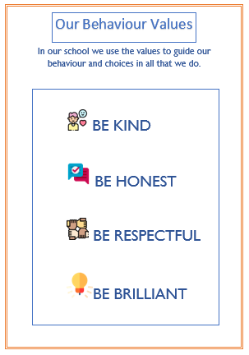

APPENDIX 4 – Brilliant Rewards

