Chacewater School – LEAP into Learning
Term: Autumn 1 | Class: Red Oaks | Theme: The Circle of Life
On this page you will find an outline of our learning this half term in Red Oaks!
Mathematics:    Number & Place Value  - read, write, order and compare numbers to at least 1,000,000 and determine the value of each digit  - count forwards or backwards in steps of powers of 10 for any given number up to 1,000,000  - interpret negative numbers in context, count forwards and backwards with positive and negative whole numbers, including through 0  - round any number up to 1,000,000 to the nearest 10, 100, 1,000, 10,000 and 100,000  - solve number problems and practical problems that involve all of the above  - read Roman numerals to 1,000 (M) and recognise years written in Roman numerals. |  | Addition & Subtraction  - add and subtract whole numbers with more than 4 digits, including using formal written methods (columnar addition and subtraction)  - add and subtract numbers mentally with increasingly large numbers  - use rounding to check answers to calculations and determine, in the context of a problem, levels of accuracy  - solve addition and subtraction multi-step problems in contexts, deciding which operations and methods to use and why.    French  - Phonetics 1-3  - Presenting Myself
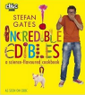  English:  Book: Incredible Edibles  Outcome: To invent a revolting recipe, disgusting decoration or hideous headdress    Book: Black and White  Outcome: write a narrative based on the stories in  Black and White |  | Science:  Living Things and their habitats    describe the differences in the life cycles of a mammal, an amphibian, an insect and a bird  describe the life process of reproduction in some plants and animals.  Animals, including humans  describe the changes as humans develop to old age.
  Computing:  Sharing information  - To explain that computers can be connected together to form systems  - To recognise the role of computer systems in our lives  - To recognise how information is transferred over the internet  - To explain how sharing information online lets people in different places work together  - To contribute to a shared project online  - To evaluate different ways of working together online |  | Art:  Botanical Drawings  Observation and Sketching Skills  Artist  John Miller
Religious Education:  What does it mean to be a Muslim in Britain today?  - Who are the Muslims in your region?  - What helps Muslims through the journey of life?  - Why is Zakah important to Muslims?  - Why do Muslims want to go on a pilgrimage?  - What does it mean to be a Muslim in Britain today? |  |   PE:  Rugby  Netball  RSHE:  Healthy and happy friendships  - Identity  - Peer pressure  - Emotional health and wellbeing

Chacewater School – LEAP into Learning
HOME LEARNING
Term: Autumn 1 | Class: Red Oaks |  | Theme: The Circle of Life
Alongside regular reading, spelling and maths home learning choose at least one of the following to complete over this half term. You might even be inspired and choose more than one!
  Find out what it means to be a Muslim in Britain today. Create a poster / PowerPoint to answer the question. |  | Create a timeline of your life or another family member, friend or pet.  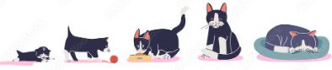 |  | Choose an animal, which hasn’t been studied in class and tell me about their life cycle.  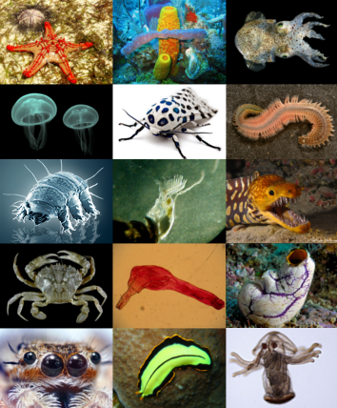
Using a shoebox make a habitat for an animal and draw a picture of that animal to put inside. Does it have all it needs to survive?  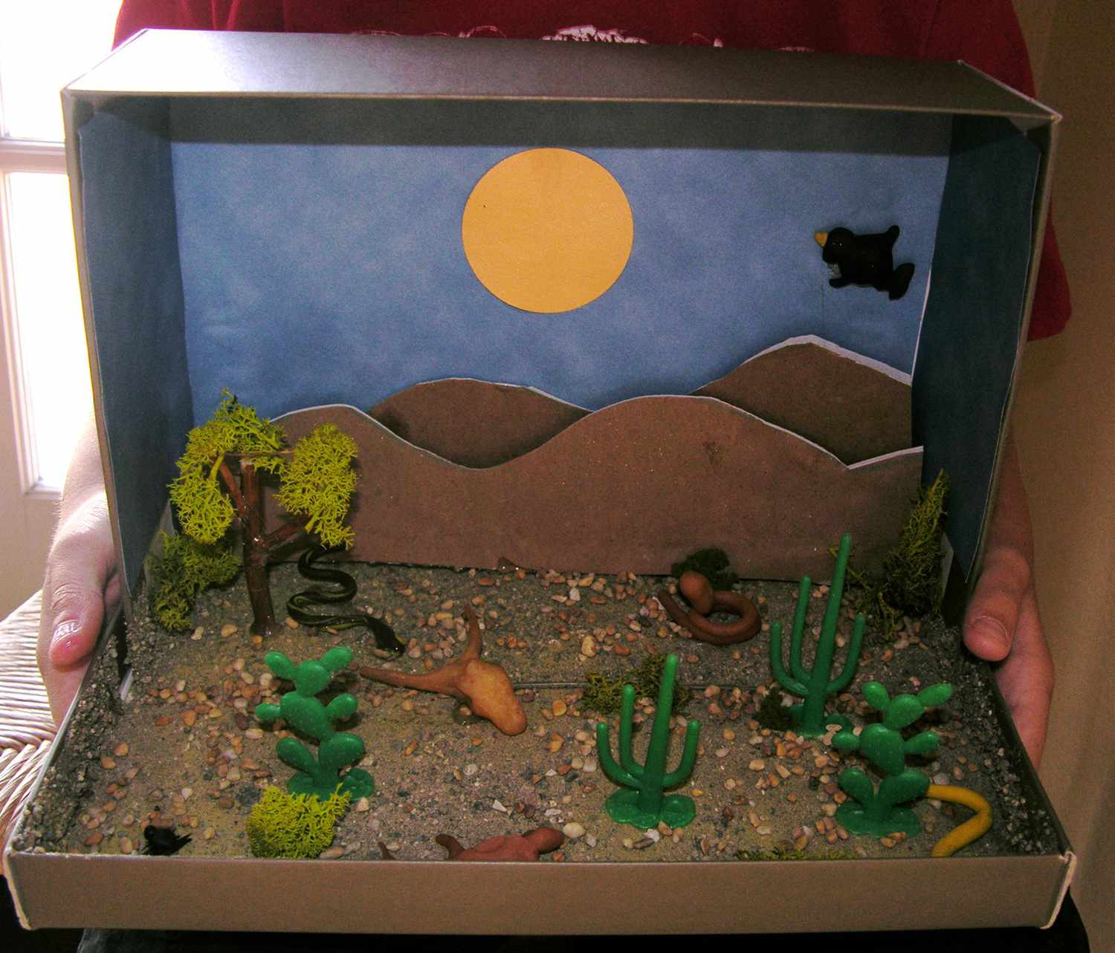 |  | Wild card!  You choose something you want to find out about animals, humans or living things and their habitats.   |  | Find out what the word metamorphosis means and create a poster to show which animals go through it.  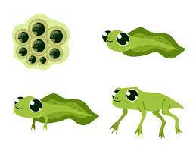
Try growing a plant in an unusual place (in a dark cupboard, in the freezer, under your bed) – record what happens.  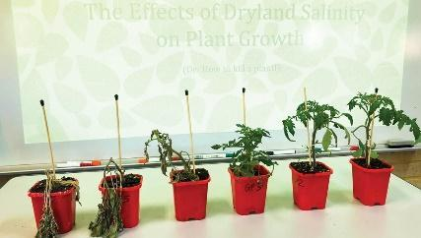 |  | Who is your favourite author?  This half-term we are reading Roald Dahl. Why not visit https://www.roalddahl.com/story-day-2023/ and see how many of his amazing stories you have read.  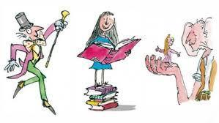 |  | Have a go at botanical drawing: find a plant in your environment and have a go at sketching it.  