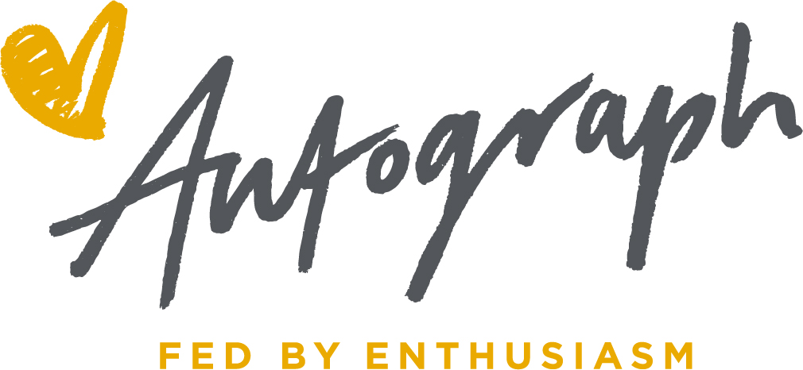

Lunch Money Debt

The issue of debt built up due to non payment of school lunches significantly increased before the schools closed because of the Covid -19 pandemic. This had a negative impact on our catering business where we are working to a very tight budget whilst providing quality food to children.

Our general policy has been to feed a child on request and there was no limit set on the numbers of meals provided whilst payment was outstanding. As a consequence, a number of large debts built up that are often not paid. This policy is no longer sustainable for Autograph and therefore the following changes will be need to be introduced.

New Policy: ALL school lunches should be paid for in advance but we do understand that sometimes things get forgotten. However, to ensure debts do not get too large, a limit of 1 weeks’ worth of meals will be the most debt that can sit on any single account (5 x £2.35 = £11.75). Once the debt exceeds this limit meals will no longer be provided until the debt is cleared.

Accounts will regularly monitored. Debt letters will be issued via Parent Pay and to the school to forward to the parent/guardian requesting immediate payment.

