
Chacewater School LEAP Curriculum

Class:  Mighty Oaks | Curriculum Driver: Science: Animals including humans Curriculum Theme: Circulatory System British values: Respect |  |  |  |  |  |  |  |  |  |  | Term:1
Local |  |  | Engaging |  |  |  | Ambitious |  |  | Purposeful
 |  | Sequence of Learning
Subject | Intent and links to previous learning | 1 |  | 2 | 3 | 4 |  | 5 | 6 |  | 7 | Outcome/Composite
Science  Animals, Including Humans | Prior Learning: systems of the body:skeletal, muscular, digestive  The know the purpose of the circulatory system | What is the circulatory system?  To be able to identify and name the main parts of the human circulatory system |  | How does our heart work?  To be able to identify and name the main parts of the heart | What are the different components found in our blood?  To be able to describe the components of blood and their functions | What does the blood transport around the body?  To be able to describe how water and nutrients are transported in humans |  | How does exercise affect my heart rate?  To understand the impact of exercise on heart rate  TAPs Enquiry Question:  Which type of exercise has the greatest effect on our heart rate? (to plan an enquiry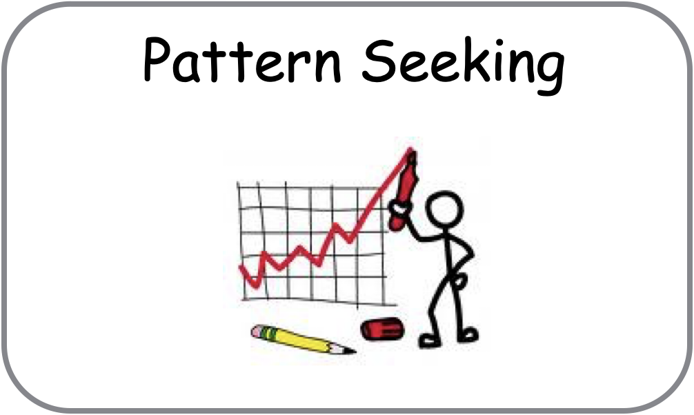/interpret results) | How can I live a healthy lifestyle?  What can damage our health?  To be able to identify how humans can live a healthy lifestyle |  |  | Understand the importance of the circulatory system and identify steps that we can all take to lead healthier lives.
Computing  Computing systems and networks: internet Communication | Prior Knowledge - computing systems and networks Y3-5  To know how the internet facilitates online communication and collaboration | To explain that computers can be connected together to form systems |  | To recognise the role of computer systems in our lives | To recognise how information is transferred over the internet | To explain how sharing information online lets people in different places work together |  | To contribute to a shared project online | To evaluate different ways of working together online |  |  | Explain which types of media can be shared through the internet (public and private) and decide what you should/should not share online.
Art: | Prior Knowledge - drawing skills | To understand how artists explore their identity by creating layered and constructed images |  | To be able to make observational drawings of peers from short poses | To be able to create a layered portrait to explore aspects of my identity, thinking about line, shape, colour, texture and meaning |  |  | To be able to share my work with my classmates, articulate how I feel about the journey and outcome | To be able to reflect upon the differences and similarities of a peers work to mine
PE & Sport | Netball  To apply the fundamental skills and to develop an understanding of the rules and tactics of the game | Bench ball - stance balance skills (Unit 3)  Stand on a line/low beam:  - raise alternate knee to opposite elbow  - catch large ball at knee, above head and away from body  - catch small ball thrown close to and away from the body |  | Individual ball skills (Unit 1 ):  move ball around egs in figure of 8  To be able to land a jump 1 foot, then the other  I can pivot on either leg | Individual ball skills (Unit 1 ):  - move ball around waist into figure of 8 around legs  To send and receive a chest, bounce and shoulder pass  I can catch the ball whilst in the air, then pivot to pass |  | Individual ball skills (Unit 1 ):  move ball around waist then alternate legs  To be able to shoot at a target (netball nets) | Individual ball skills (Unit 1 ): criss crosses with and without a bounce  To be able to mark and defend a goal and intercept the ball  I can work as a team in formation (positions for high 5 netball) | To be able to use and apply learnt skills and attacking and defending tactics appropriately in a high 5 netball game |  |  | Apply learnt skills and simple tactics in small game situations
PE & Sport | Rugby  To apply the fundamental skills and to develop an understanding of the rules and tactics of the game | To be able to move with the ball with accuracy, confidence and control  To be able to find and use space |  | To be able to send and receive the ball accurately and laterally at chest height | To be able to perform skills of passing with speed and accuracy  To be able to work together with others to invade space | To be able to use specific modes of attack (formations)  To be able to defend to deny opposition space |  | To be able to use attacking and defending skills  To be able to combine and perform skills with control in a variety of situations | To be able to apply learnt skills and tactics in small tag rugby game situations |  |  | Apply learnt skills and tactics in small tag rugby game situations
Music | To build on prior learning and be able to play a melodic instrument with increased skill as a class. | To be able to recall chord boxes: c, am, f and g7, introduce d7 and g. |  | To be able to change chords and play along with a number of different tunes | To understand time signatures: ¾ and 4/4, and the difference between straight and ‘swung’ rhythms.  Play with different rhythms to accompany tunes. | To be able to create melody lines when plucking |  | To understand how to practise a skill in order to improve own performance. | To perform and record a piece on the ukulele to share on Soundcloud. |  |  | Develop own levels of expertise in playing the ukulele.
French:  At the tea room | This is a unit that consolidates much of the grammar covered in our Early Learning teaching type (nouns, gender, determiners and plurality) so that pupils can say and write what they are ordering to eat and/or drink using a wider range of vocabulary | In this unit the children will learn how to:  - Recall a wide variety of foods, snacks, and drinks (with their indefinite article/determiner) typically served in a salon de thé.  - To understand better how to change a singular noun to plural form.  - Perform a short role-play ordering what they would like to eat and drink. |  |  |  |  |  |  |  |  |  | To be able to order food and drink in French through role-play
RE: Why do Hindus want to be good? | Prior learning -  Year 3: Unit L2.7 What do Hindus believe God is like?  To make connections between Hindu beliefs studied and explain how and why they are important to Hindus. | To be able to recall past learning from U2.7L (Y3). Set out new learning about Hindu beliefs. |  | Who or what is Brahman? | What is atman? What can be learned about atman through a Hindu  story? | What is samsara? Why is atman important? What else is important? |  | How might dharma affect the way someone lives their life? | What is ahimsa and how does it affect the lives of Hindu people? |  | Why do Hindus want to be good? | Understand and be able to discuss key concepts in Hindu beliefs of the best way to live a good life.
RSHE: Healthy and Happy Friendships | Understanding Relationships and Feelings | To be able to demonstrate ways of resisting pressure that threatens personal safety and to demonstrate skills to help us be assertive against pressure to take risks |  | To consider the benefits and costs of trusting other people. | To be able to describe ways that change can affect our friendship and to identify ways that our feelings may change towards others | To identify our values around relationships |  | To be able to explain why we might feel a range of mixed emotions and that this  happens to everyone | To be able to talk about different situations which could make us feel different things  and respond in a particular way. |  |  | Know how relationships evolve as we grow, and how to cope with a wider range of emotions
Reading Opportunities  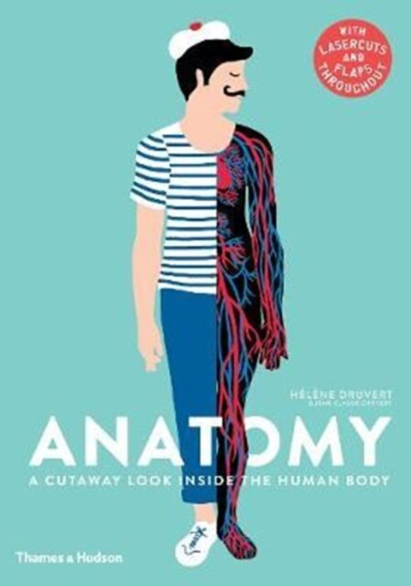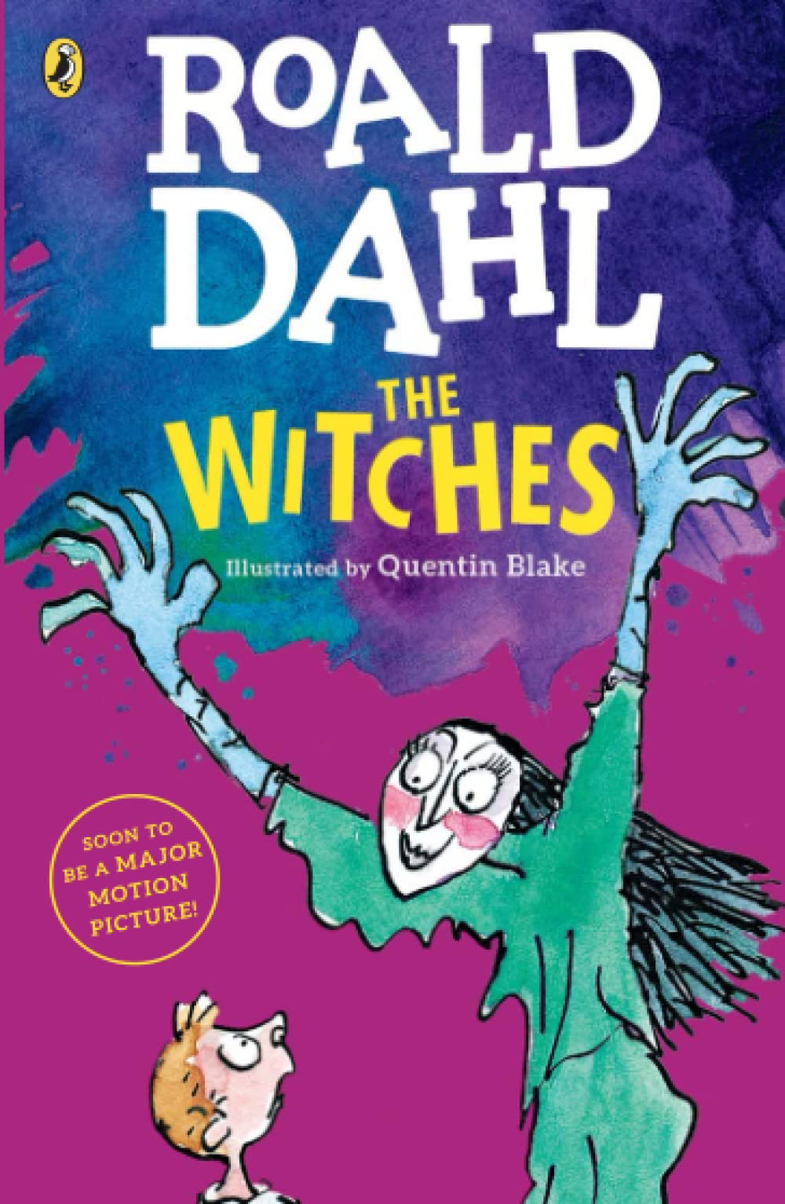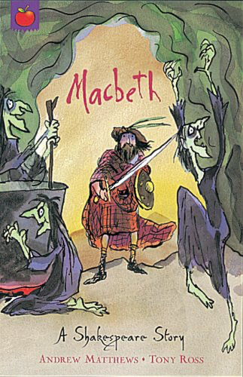 |  |  |  |  |  |  | Personal Development  Healthy Eating; Drugs, alcohol & tobacco Science: recognise the impact of diet, exercise, drugs and lifestyle on the way their bodies function  First Aid  Physical Health: make a 999 call; concepts of basic first-aid

