



5th December 2025

Dear Parents and Carers,

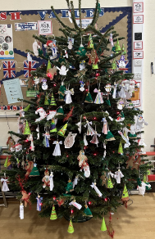
Christmas has truly arrived at Chacewater! This week, the festive spirit has been in full swing. Our children have been busy creating beautiful decorations for our Christmas tree – a huge thank you to Chacewater Garden Centre for their generous support. On Tuesday, we celebrated with our grand light switch-on event, complete with Santa Wi-Fi and a glitter plunger! It was a magical moment that really set the tone for the season.

Unfortunately, the weather had other plans for our football tournament, but we still managed to play an away match on Thursday against Truro Learning Academy. While the result didn’t go our way, the team showed fantastic promise and came so close to scoring – we’re convinced a VAR check would have given us that goal!

Today, Mighty Oaks enjoyed a brilliant trip to the Maritime Museum to deepen their learning about the Vicious Vikings. Thankfully, the trip was indoors, which was a relief given the weather!

We were also really pleased to show off our developing nature area to Jeff Hick and Esmond Phillips, who have kindly donated funds to help us buy a log seating area and continue developing this space. A HUGE thank you to them for their generosity and also to Mrs White for all of her hard work in making this happen! Here you can see Harry, Madison and Astrid enjoying the area – even if it was a little wet!



Next week is packed with festive fun: Wednesday brings Christmas Lunch and Jumper Day, and on Friday we have our whole school trip to the pantomime to watch Aladdin! We can’t wait to share these special moments with the children as we head towards the end of term.


I hope you all have a great weekend

Don’t forget it is our Christmas Fayre tomorrow in the village hall from 11am!


Mr Hick

FROM THE PTA

Thank you for all of your generous donations to our Christmas Rainbow Raffle

The raffle will be drawn at our Christmas Fayre on Saturday 6th December, 11am - 3pm at Chacewater Village Hall. Please come along to support our school and join in some festive fun!

Clubs
A reminder that clubs have now finished for this term

Christmas Lunch and Jumper Day – 10th December

On Wednesday 10th December we will be having our Christmas Lunch in school. On this day children can wear Christmas jumpers to school.


Christmas Performance Dates – We will close the forms for these on Monday morning.

- Acorns Nativity – Thursday 18th December. Performance at 2.00pm. Request Tickets HERE.
- Seedlings & Buds Nativity – Tuesday 16th December. Performances at 9.30am and 2pm. Request Tickets HERE.
- Key Stage 2 Carol Concerts – Wednesday 17th December. Performances at 1.45pm and 6pm. Request Tickets HERE.


Panto!
As you know, we are really excited to be able to take all of our children to the pantomime, Aladdin, at the Hall for Cornwall on Friday 12th December. To help us with organising this event please complete the form HERE (if you haven’t already).

Last Day of Term
Our last day of term is Friday 19th December and we will finish at 1pm on this day.
Attendance

This week we have been conducting routine monitoring of attendance in school. As part of this and in line with our policy some families will have received a letter about school attendance.
We would like to once again remind everyone about the importance of school attendance. Achieving high school attendance is a national priority. Chacewater school data clearly shows a correlation between high attendance rates and high achievement. We want our children to achieve excellent attendance in line with national average. Illness usually appears as a block of time off school. We review attendance patterns each week and look for unbroken and broken weeks as a key indicator. We would not usually expect that children would have more than one or two broken weeks in the course of an academic year. Regular broken weeks are a cause for concern and we will offer support to families where there are more frequent broken weeks, in line with our attendance procedures. The impact broken weeks and missed learning can have on a child’s education (taken from national data) is illustrated below for guidance:
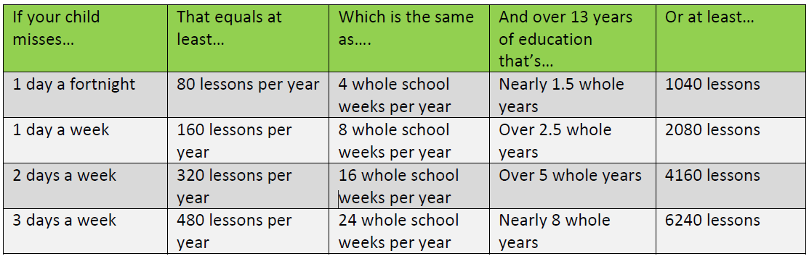
As a school we follow the Truro and Penwith Academy Trust policy which can be found HERE. You will be aware that there have been a number of changes to the issuing of penalty notices and there is little or not discretion for headteachers regarding these. Attached with this newsletter is a leaflet about penalty notices but it is important to note:
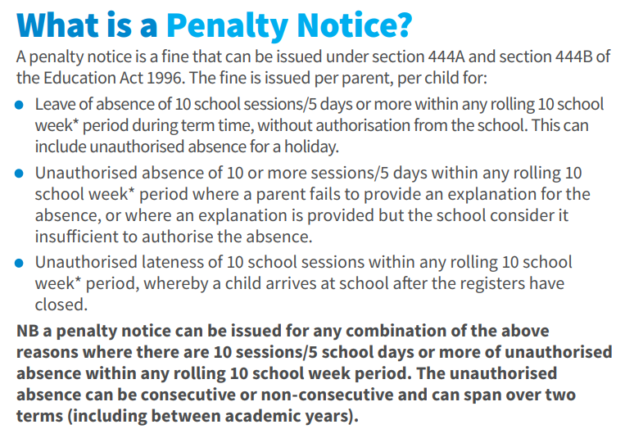
Please also be aware of the below:
If your child is absent from school without authorisation, you will be committing an offence under the Education Act 1996. We may submit a request to Cornwall Council for a Penalty Notice to be issued, in accordance with Sections 444A and 444B of the said Act. Penalty Notices are issued per liable parent, per child and each carry a fine of £80 if paid within 21 days or £160 if paid after this but within 28 days.
If your child is further absent from school without authorisation within any 3-year period, you will be committing a further offence under the Education Act 1996. We may submit a request to Cornwall Council for a Penalty Notice to be issued, in accordance with Sections 444A and 444B of the said Act. Penalty Notices for a second offence are issued per liable parent, per child and each carry a fine of £160, payable within 28 days.
Importantly, fines per parent will be capped to two fines within any three-year period. Once this limit has been reached, other action such as a parenting order or prosecution will be considered.
Failure to pay the Penalty Notice may also result in legal action. If you are prosecuted and attend court because your child has not been attending school, you could get a fine of up to £2,500. Cornwall Council may also apply for the costs incurred in taking the matter to Court, including legal costs.
Absence not authorised by the school may also result in a prosecution in the Magistrates’ Court under Section 444(1) or Section 444(1A) of the Education Act 1996, leading to a fine of up to £2,500 and/or a custodial sentence. Again, Cornwall Council may also apply for the costs incurred in taking the matter to Court, including legal costs.
Money raised from fines is only used by the local authority to cover the costs of administering the system, and to fund attendance support. Any extra money is returned to the government.

Starting School - September 2026


Acorns 2026!
Calling all Reception Starters 2026
If your child was born between September 1, 2021, and August 31, 2022, you need to apply for a reception place.
You can now apply for your September 2026 place so it is the perfect time to book onto one of our open mornings and see what we have to offer here at Chacewater School.
Securing the right school place for your child is an important step for all parents and carers. This is why it’s crucial to get the right information early on and submit your application before the deadline.
If your child has an Education Health and Care Plan (EHCP) you do not need to fill out an application. For further information about transitions for children and young people with an EHC plan, please visit Cornwall Council's website and scroll down to the 'Phase Transfer' section. You can also email the Statutory SEND (Special Educational Needs & Disabilities) Service on ehcreviews@cornwall.gov.uk or if you would like to speak to someone you can call the SEND System Navigators on 01872 324242.
DEADLINE FOR APPLYING: Reception classes - January 15, 2026.
https://www.cornwall.gov.uk/.../school.../school-admissions/


Dates For Your Diary
Week Beginning 1.12.25 | Last week for after school clubs.
6.12.25 | PTA Christmas Fayre – Village Hall
Week Beginning 15.12.25 | Christmas Performance Week.
12.12.25 | Whole School Christmas Panto
15.12.25 | Carol Concert - Provisional Date and TBC
19.12.25 | End of Term – 1pm Finish
5.1.25 | Start of Spring Term
26.1.25 | Inset Day

Term Dates
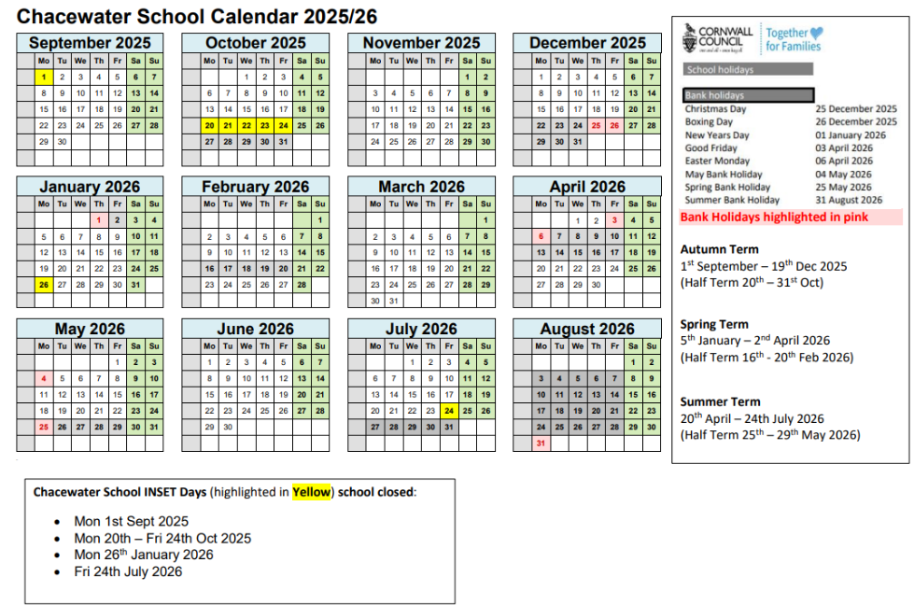


GOLDEN AWARD WINNERS

ACORNS
SEEDLINGS
BUDS
YOUNG OAKS
BUR OAKS
RED OAKS
MIGHTY OAKS

Signposting




Cornwall Toy Appeal – Rewind Radio

Cornwall Toy Appeal — helping bring smiles, comfort, and hope to children who need it most.
This year, we’re proudly supporting three incredible local charities:
💛 Royal Cornwall Hospitals Charity
💚 Children’s Hospice South West
💙 Penhaligon’s Friends
Each of these charities plays a vital role in supporting children and families here in Cornwall — from those spending Christmas in hospital to those living with life-limiting conditions or coping with the loss of a loved one. Together, we can help make their festive season a little brighter.
Collection of donations will take place from the 10th of December to ensure they reach the charities in plenty of time for them to pass the gifts on to families before Christmas.
We’re collecting new, unwrapped toys and gifts suitable for children and young people — from babies right up to 18-year-olds. Every donation, big or small, helps bring joy to a local child or teenager this Christmas.
With your help, we can make sure every child feels the warmth and joy of Christmas.
All our locations can be found here: https://www.rewindradio.co.uk/toyappeal/

