
CHACEWATER PRIMARY SCHOOL
EARLY YEARS STRATEGY for 2025/26

INTENT
Chacewater Schools Vision.

At Chacewater School, we base our love of learning through a broad and balanced curriculum – fostered through the earliest stages of their academic lives, right throughout their journeys in our school. Therefore, in our Foundation Stage we strive to deliver a wide and varied learning experience, where we are fully committed to developing each child’s unique potential. Thus, we promote children to lead their own learning through a balance of children’s interests and that of the skills we want them to fulfil based through the Development Matters Strategy and those that will help them as they begin their journey through our school. These areas are then explored and deepened further by not only their surroundings, but the immediate learning opportunities nurtured by the staff. Over the years we have adapted how we teach, allowing us to experience with rotational groupings which are adult led, independent groupings where the children lead or opportunities which are based around previous learning experiences to captivate what they children have learnt over time.

The Early Years Framework, accompanied by Development Matters and Birth to 5 will then be pieced together by inspirational texts and hook books linked to the child’s interest, incorporated and filtered throughout all learning experiences – Maths, Phonics and our afternoon sessions.

Successful transitions

At Chacewater School our vision for success stems back from our belief that time and dedication initiated in the Early Years setting with parents, carers and agencies, builds fundamental relationships with children’s families upon arrival to our school. Practitioners in the Early Years setting make exceptional links with desirable agencies and nursery provisions, whereby children meet the class teacher long before arrival, as well as discussing their interests and attainment with appropriate adults.
Our thoughtful and thorough parent appointments, open classroom and staggered start program, allows parents to engage in the school’s ethos prior to their children starting school. These exceptional links allow the children and their families to have a smoother transition into school life, allowing the children to have an essence of self confidence and awareness immediately and their relationships with peers and staff have already been made.

We are aware that children joining us will be attending from a range of environments, cultures, backgrounds and experiences. Therefore, children who attend an Early Years setting at a TPAT school will be supported to transition into our settings, to ensure all children have the same, strong start. We offer a mixture of:
- ‘stay and play’ sessions
- Home visits
- Parent meetings
- Visits to previous settings
- Teacher and leadership presentations
- Informal events, such as family picnics
- Transition packs for families

What do we want to achieve?

In the Foundation Stage we believe that our children should feel safe and happy in a stimulating learning environment, which allows them to reach their best academically, but also developing their thirst for knowledge, fostering a love of learning and leave our school with exceptional independent learning skills.

From this, we expect that all children within the Early Years setting make strong progress from their accurate starting points assessed through their initial baseline assessments. Along with the statutory baseline assessments that all reception classes are required to carry out, our school undertake our very own assessments too. These baseline statements are taken from the statutory framework and Development Matters Framework and are used to address areas of weakness and strengths within the earliest stages of the children’s schooling experiences. These are recorded and used to plan the provision for the cohort, addressing all areas of particular focus. Practitioners in the foundation stage make professional judgements as to where they believe the children are working at. These then link and are continuously monitored through the observations recorded on Tapestry and by having termly meetings with SLT using Target Tracker to support.

How do we do this?
All staff in the Early Years sector have a clear vision for Chacewater School and how we deliver our provision and why. This is outlined in our long term plans, planning for each area of learning, learning landscapes and discussions with all practitioners in the room.
Children have a passion for learning through the thought out and planned provision set out linked to the overarching themes and links to our hook books.
Children will learn a broad, balanced and stimulating curriculum which has an emphasis on the development of reading, vocabulary and writing.
Children deepen their learning further through the use of well planned and thought out continuous provision linked to our overarching themes and hook books.
Children to have opportunities to access writing throughout daily provision.
Children to be taught a high standard of phonics using the Read Write Inc Program.
For parents to be involved in the children’s learning in the foundation stage through parent meetings regarding the learning that takes place, Read Write Inc updated information.

Personal Development
Our TPAT approach to personal development in the Early Years is centred on nurturing confident, resilient, and curious learners through a rich and varied curriculum that reflects the unique locality of Cornwall. We place strong emphasis on developing the whole child—emotionally, socially, physically and spiritually—through high-quality interactions, planned experiences, and a language-rich environment. Children are encouraged to form positive relationships, understand their emotions, and develop a sense of belonging within their school and wider community. Real-life experiences such as exploring local beaches, woodlands, and farms, as well as engaging with Cornish traditions and seasonal events, support children in making meaningful connections with the world around them. Our approach ensures children build a secure foundation for lifelong learning, with personal development woven through every aspect of the Early Years curriculum

Curriculum Overview

Each year a curriculum overview plan is created based on the information we have received from the parents and children during the come and play sessions, parent appointments, nursery visits etc. These overviews can change overtime dependent on the cohort and children’s interest, but factor in general themes to cover (based on the expectations of those in the foundation stage using Development Matters and Birth to 5) and linking possible texts and wow moments.

We aim to cover the 7 areas of the EYFS framework. These areas are broken down into:

Communication and Language
Personal, Social and Emotional Development
Physical Development
Literacy
Mathematics
Understanding the World
Expressive Arts and Design.
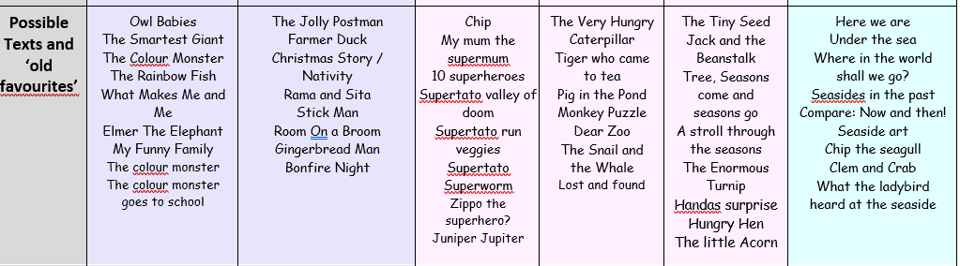
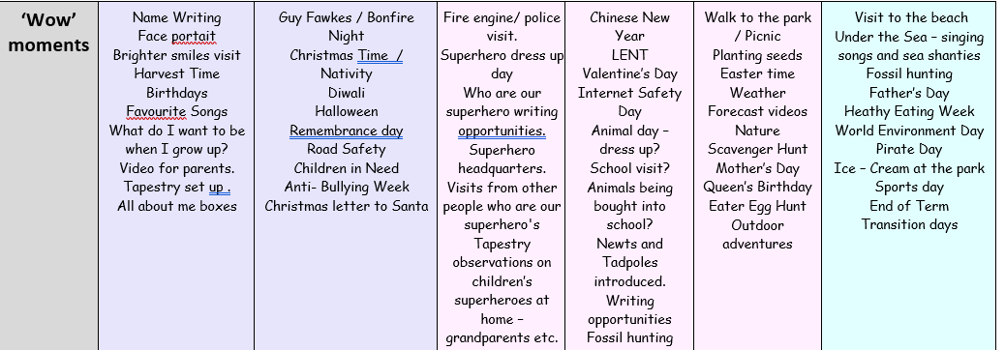
An overview of how we deliver these areas are broken down in the implementation.
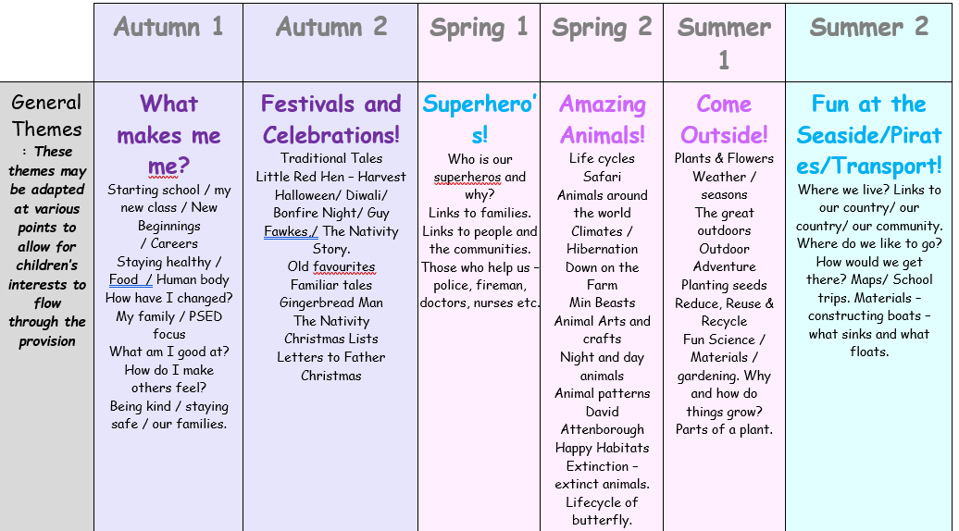

Implementation
Transition into Reception and engagement with parents

Starting school can be a daunting affair for both children and parents. At Chacewater School we make every effort to ensure this transition is as smooth as possible. Once we have the confirmed list of new starters (usually after the Easter holidays) we will write to everyone and invite them to a personal meeting with the Head teacher and Reception Teacher so we can begin to get to know the family.

In the summer term we plan a number of 'Come & Play' sessions for children who will be starting school with us in September. The class teacher will also make a personal visit to children in local pre-school settings. This will give her a chance to talk to your child's key worker and find out a little more about them and see them in an environment they are comfortable in. The first couple of weeks at school will begin staggered to allow practitioners to fully know all children before their full time arrival and for children to feel safe and secure in their new setting.

Engagement with parents

We meet parents of new starters during the Summer Term. First, at a planned parent’s appointment and then parents are invited to an Open Afternoon to meet the uniform provider, After-school club, school caterers and Friends of Chacewater School. They will also have the opportunity to meet Governors, the Acorns Class staff and visit the classroom with their child.

A 'Starting School' booklet is provided to support families with all the information they might need about our school. This booklet is updated every year to make sure it reflects the needs of our families.

We also use Tapestry as a mean of communication during the week for parents and practitioners in the Early Years setting. This also allows parents and guardians to engage in the provision that is taking part in the classroom.

Parents are also greeted by the class teacher every morning as they drop and pick up their children.

During the Autumn Term, parents are invited into the classroom to engage in a presentation with the class teacher and practitioners to discuss how Early Years is taught.

Along with the rest of the school, parents are also invited in during the first and second half term for a parent appointment and to discuss their child’s progress.

Baseline assessment

Baseline assessments are compared to their nursery end of year assessments and information the parents provide us.
We use and write our own baseline activities for the specific and prime areas of learning. We also complete the government statutory baseline assessments.
We aim to complete all baseline assessments within the first month of the children starting school. We use these assessments to reinforce planning for the upcoming term.
These baseline assessments are carried out through a mixture of 1-1 tasks, small groups and observations. We use the criteria in 3-4 development matters to help us plan our assessments.
When analysing the data, we carefully look at the strengths and areas of improvement within both the prime and specific areas of learning.
Summative assessments are then recorded on Target Tracker every term.
Planning reflects the priorities recorded in the baseline, alongside the children’s interests and long term plan and intent for EYFS.
Baseline assessments are then compared to those who reach the ELG by the end of the academic year.

Classroom Organisation and Balance of child-initiated activities and adult led activities.

A thoughtful process is constructed to ensure that all children in the Early Years Foundation Stage are accessing a range of different adult led activities and child led activities.

Whole class direct teaching is carried out for Maths, PE and our Themes (the wider curriculum).
Differentiated smaller groups are carried out for Read Write Inc.
We have 1-1 work which is carried out for Read Write Inc interventions.
NELI/ Language Link is carried out with targeted children.
Continuous provision is carried out twice a day. Once in the morning and in the afternoon.

Our Curriculum
Prime Areas
In our Early Years setting, the Prime Areas of learning—Personal, Social and Emotional Development (PSED), Physical Development (PD), and Communication and Language (C&L)—are given the highest priority, as they are fundamental to every child’s ability to access and succeed in all other areas of the curriculum. These areas form the essential building blocks for lifelong learning and development, enabling children to form positive relationships, regulate emotions, communicate effectively, and engage confidently with the world around them. We use carefully structured, school written Progression of Skills documents to guide and support development across the Prime Areas and the wider EYFS curriculum, ensuring that learning is consistent, responsive, and aligned with each child’s individual needs and stage of development.

Communication and Language –

Supporting communication and language development is a key priority across our trust and particularly at Chacewater and aligns with national focus areas. All pupils are screened upon entry to EYFS using one of the following evidence-based tools: Language Screen or Language Link. This allows us to identify needs early and provide targeted support.
We use structured interventions including the Speech, Language and Communication Progression Tool, Talk Boost, and NELI (Nuffield Early Language Intervention) to help close gaps and accelerate progress. Children benefit from a rich language environment where both planned activities and high-quality incidental interactions are used to develop vocabulary, expressive language, and listening skills, laying strong foundations for future learning and communication success.

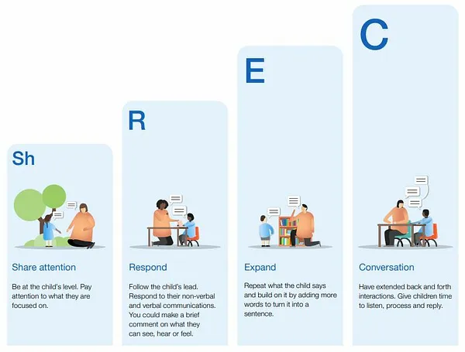
Settings across TPAT have adopted the ShREC Approach, (Education Endowment Fund) to promote shared attention and back and forth conversation in the early years. Practitioners are trained to improve early education through high quality interaction. To continue to support this, at Chacewater School, we make sure we also do the following things:
- Daily circle times
- Modelling spoken language and sentence structure
- Daily story sessions
- Opportunities to explore new vocabulary with new hook books (signposted in planning)
- Sentence stems, encouraging our children to talk in full sentences when speaking or asking questions.
- Small group work
- Acting out stories and narrating them.

Physical Development –

At Chacewater, we recognise that physical development and health are fundamental to nurturing happy, healthy, and engaged learners. All pupils spend sustained periods of time outdoors each day, where they are encouraged to explore, move, and play, developing both their gross and fine motor skills in meaningful ways. Our outdoor provision is planned with the same care and intention as our indoor environments, ensuring it supports all areas of learning, particularly physical development. Children are taught the importance of hygiene and are supported to develop personal care independence, such as handwashing, toileting, and self-care routines.
At Chacewater, we also make sure we are also highlighting the importance of gross and fine motor skills. To do this we recognise that carrying out these activities weekly for the children to engage in, can support this:
- Real PE
- Gross and Fine motor skills – mapped out in our planning.
- Pen pal activities – to support our pinchy pencil grip when writing
- Funky finger activities planned in our continuous provision planning, aimed to target children who need additional finger strength activities.
- Bikes.
- Outdoor adventure.
- Equipment used during playtimes.
- Targeted tough trays to build finger strength.
- Dough disco.

Personal Social and Emotional Development –

Here at Chacewater, personal development is at the heart of our EYFS approach, ensuring that children grow into confident, resilient, and caring individuals. Adults model positive relationships and self-regulation throughout the provision, helping children learn how to interact kindly, resolve conflicts, and manage their emotions. Pupils are supported to recognise and name their feelings, laying the foundation for emotional literacy and wellbeing. We use the colour monster to support this daily. Through play and daily routines, children learn to socialise, work co-operatively, and become responsible, respectful citizens. We foster resilience and confidence by encouraging children to embrace challenges and try new things, celebrating effort and perseverance. A strong emphasis is placed on having a healthy body and mind, with children learning about balanced diets and being encouraged to enjoy the healthy foods provided.

At Chacewater we do these things to support PSED
- Regular circle times
- Modelling good friendships through hook books
- Working through the colour monster stories – colour monster board and daily work with how we are feeling and why – understanding our emotions.
- Promoting good behaviour values through our schools’ behavioural values and also our own adapted class rules.
- Providing children with opportunities to work in smaller group settings, modelling play, interactions, sharing etc.
- Healthy eating promoting through hook book stories, supertato, hungry caterpillar.
- Building strong relationships from the start of their school experiences, nursery visits, come and play sessions, settling in periods.

Literacy - Early Reading – Read Write Inc

Reading is at the heart of our curriculum.

In the Early Years, phonics is taught through a consistent, synthetic systematic phonics programme that begins immediately when children join the setting. The approach is proactive, with a strong emphasis on helping all pupils to keep up with the pace of learning, rather than having to catch up later. Progress is closely tracked and assessed to ensure each child is making steady development in their phonics knowledge. Reading materials are carefully matched to the phonemes that have already been taught, allowing children to apply their learning with confidence and success. The most skilled practitioners work closely with the most vulnerable pupils to provide targeted, high-quality support, and the phonics programme is regularly shared with parents to ensure they are informed and able to support learning at home.

At Chacewater School, Phonics is delivered throughout KS1 and EYFS similarly.

How do we make sure children make progress?
- Phonics is taught daily following the Read Write Inc (RWI) progression of sounds to ensure a systematic approach.
- Phonic lessons follow the same sequence of teach, practise, revise, review and apply, including daily partner reading. Planning includes assessment for the graphemes taught. Phonics is assessed half termly to identify gaps in learning to inform future planning and intervention.
- The comprehension aspect of reading is taught through whole class guided sessions. The teachers focus their questioning on the 6 reading domains: clarifying, questioning, explaining, retrieval, summarising and predicting. To support the children’s understanding, dual-coding through ‘The Pawsome Gang’ is used.


In the Early Years Foundation Stage, we delivery phonics from the start, immersing children with sound exposition from the start of their experience in school. During this period, we assess the children using our baseline assessments and teach the initial set 1 sounds following the Read Write Inc programme.

The teacher delivers a speed sound lesson to the whole class which includes the ‘sound of the day’’, rhyme and handwriting process and objects that also begin with the sound of the day. We also link early reading, oral blending and CVC recognition into these sessions as well.

How do we match the pupil’s reading books to their phonic ability?
Through the Read Write Inc programme, children are given books that match the sounds that they have been taught. Children are then able to read with confidence and practice sounds at home.
- Pupils are assessed daily in phonics as well as half termly using the RWI assessments. Assessment then informs which books match to the pupil’s phonic ability.
- Staff in EYFS are responsible for changing and or checking the pupil’s reading books.
- Pupils who are learning phonics in EYFS take home three books: a book bag book, a read write story book and a book for pleasure.

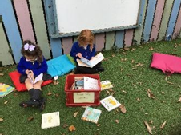
How do we promote a love of reading?

Reading underpins our schools’ approach to learning and therefore as well as this, phonics and reading is essential to all areas of the curriculum. Continuous provision activities are set up with reading at the heart of what we teach. As well as this, hook books underpin the children’s learning and are used to encourage discussion and promote each topic which is taught across the EYFS year. Children are given enriching opportunities to delve into storytelling and sequencing using story stages, story spoons and tough trays that link to the book of the week. We also visit the Library weekly to create a essence of reading for pleasure.

At Chacewater, our EYFS writing strategy recognises that children must be developmentally ready to write, and as such, we place a strong emphasis on fine motor activities to build the physical skills required for writing. Correct letter formation is a key focus across all settings, ensuring children develop good habits from the outset. Writing is primarily taught through systematic phonics programmes, enabling pupils to apply their growing phonic knowledge to spell and write with increasing independence. During the year we also enhance this with rich, imaginative approaches such as Drawing Club and storytelling prompts, which help to inspire a love of writing. Adults consistently model writing to demonstrate the writing process, vocabulary choices and sentence construction. In independent provision, children have access to varied opportunities to write for a range of purposes. Practitioners carefully plan for children to write phonemes, words and phrases that align with their phonics learning, ensuring progression and consolidation in meaningful contexts.

Approaches to building Early Mathematical skills

At Chacewarer, our strategy for teaching mathematics in the Early Years is rooted in a mastery approach, ensuring that all children develop a deep and secure understanding of number. Teaching is carefully planned with an emphasis on building strong number sense through high-quality, consistent programmes. Mathematical learning is made meaningful by relating concepts to real-life experiences, enabling children to apply their understanding in practical, purposeful contexts. Within continuous provision, carefully selected resources are used to support exploration, promote mathematical talk, and deepen conceptual understanding. Through this integrated approach, we aim to foster curiosity, confidence, and a lifelong love of maths from the very beginning of a child’s learning journey.

At Chacewater, we use Mastering Number alongside taking snippets from White Rose. Developing a strong grounding in number is essential so that all children develop the necessary building blocks to excel mathematically. Children should be able to count confidently, develop a deep understanding of the numbers to 10, the relationships between them and the patterns within those numbers. In Early Years our aim is to build a strong association with number and a deepening understanding of how numbers can be characterised using varied resources, environments and representations to help them with this.

By providing frequent and varied opportunities to build and apply this understanding - such as using manipulatives, including small pebbles and tens frames for organising counting - children will develop a secure base of knowledge and vocabulary from which mastery of mathematics is built. In addition, it is important that the curriculum includes rich opportunities for children to develop their spatial reasoning skills across all areas of mathematics including shape, space and measures. It is important that children develop positive attitudes and interests in mathematics, look for patterns and relationships, spot connections, ‘have a go’, talk to adults and peers about what they notice and not be afraid to make mistakes.

How do we deliver this at Chacewater?

- Maths is taught over the course of the week. Mondays we teach the Shape, Space and Measure element with support from White Rose. Tuesday-Friday we teach Mastering Number and teach children a number of the week.
- Maths sessions always begin with a teacher input. Number of the week (focusing on NCETM and Numberblocks). Different ways to represent a numeral or number, is taught at the beginning of a lesson to allow children to see that numbers can be represented in a variety of different ways: eg: hands, fingers, dice, numicon etc. This year we are also taking part in the Mastery Number project.
- Children access learning around the room in a continuous provision style, allowing teachers and TA’s to assess what the children already know and what they don’t. This then helps the delivery of the rest of the week’s planning. Teacher and TA’s then revisit this on their Friday sessions and assessments and observations of the children in that week are then put into a folder on Tapestry and are assessed as a group and then as an individual child. Pictures are uploaded onto Tapestry of the 4 sessions children all took part in over the course of the week.
- Maths sessions are the separated into three groups (adult led). These groups are always practical and looking over different ways of visualising and representing. Children rotate through these groups over the course of the week and each teacher/TA has an objective (taken from the Development Matters Framework) in which helps assess the children and what they can/can’t do. This then helps reinforce planning for the next week.
- Our independent groups where the children access the provision themselves are broken down into – Learning that has been taught previously, learning that links to Mastering Number, Learning that links to the number of the week.
- Maths is recorded on Tapestry and we use a hashtag system to distinguish what children know.
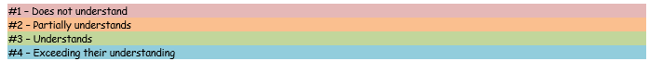

Understanding the World

At Chacewater we approach Understanding the World through a range or different themes over the course of the year. These themes focus on the Humanities curriculum across the wider school, supporting children to develop a strong sense of identity and their place in the world. We place great importance on grounding children’s understanding in real-life experiences and the local context, making full use of the rich Cornish landscapes, heritage, and traditions to foster curiosity and a connection to their community. Through purposeful and carefully planned experiences, children begin to explore geography, history, and culture in meaningful ways that are rooted in their everyday lives. At the same time, we recognise the need to extend children’s horizons beyond Cornwall by intentionally planning opportunities to learn about different countries, cultures, and times outside of their own experiences. This includes introducing children to global diversity through stories, celebrations, visitors, and resources that reflect a wide range of communities and traditions. In doing so, we ensure that every child begins to build the cultural capital and global awareness they need to thrive in an increasingly interconnected world.
At Chaewater we plan for Understanding the World but we also incorporate this into our daily routines
- Opportunities to explore the world through outdoor adventure.
- Exploring where we live.
- Discussing other countries linked to hook books – particularly our Animal topic in Spring 2.
- Opportunities to look at those who help us in our local community, visits from police, fire fighters etc.
- Visiting local places.
- Investigating maps.
- Looking at people who are of particular significance – Guy Fawkes etc, Jesus (The Nativity).
- Lifecycles of animals and plants.
- Seasonal changes.

Expressive Arts and Design

Expressive Arts and Design is a vital part of our EYFS curriculum, encouraging children to develop their creativity, imagination, and confidence in expressing themselves. From the earliest stages, children learn to use a range of tools and materials to create, explore, and communicate their ideas. They are supported to invent and recount stories alongside peers and adults, bringing their imaginations to life through role play, music, and art. Our curriculum includes a carefully planned progression of songs and rhymes, enriched by links to local artists and traditional Cornish songs that help foster a strong sense of cultural identity. At the same time, we intentionally broaden children’s creative horizons by introducing them to music, stories, and artistic styles from a wide range of cultures, helping them appreciate diversity and new perspectives. Where possible, children visit local places of cultural interest such as the Tate St Ives and Hall for Cornwall, deepening their engagement with the arts. We also provide opportunities for children to share their creations with the wider community, building pride in their achievements and strengthening connections beyond the classroom.
At Chacewater School –
- Role play area opportunities linked to theme or hook book.
- Story stages to act out known tales or stories familiar to them.
- Daily creating tables.
- Opportunities to mix colours and paint inside and outside.
- Use of various materials to manipulate for purpose.

Overarching themes and books used throughout the year
During the first few weeks, we focus on the Colour Monster and the Colour Monster goes to school. In class we have a colour monster chart which we talk about regularly with the children. This chert is visible all year around.

Autumn 1 – All about me.
Hook books – Owl Babies, The Smartest Giant, The Colour Monster, The Rainbow Fish, What Makes Me and Me ,Elmer The Elephant , My Funny Family.

Autumn 2 – Festivals and celebrations
Hook books – The Jolly Postman, Farmer duck, Christmas story/ Nativity, Rama and Sita, Stick man, Room on a Broom, The gingerbread man. Bonfire Night

Spring 1 – Superheroes
Hook books – Chip, My mum the supermum, 10 superheroes ,Supertato valley of doom ,Supertato run veggies ,Supertato , Superworm, Zippo the superhero?, Juniper Jupiter

Spring 2 – Amazing animals
Hook books – The Very Hungry Caterpillar, Tiger who came to tea , Diary of a wombat ,Pig in the Pond, Monkey Puzzle, Dear Zoo, The Snail and the Whale, Lost and Found, What the ladybird heard.

Summer 1 – Come outside
Hook books – The Tiny Seed, Jack and the Beanstalk , The Enormous Turnip , Handas surprise, The Acorn.

Summer 2 –At the Beach
Hook books – Clem and Crab, What the Ladybird heard at the seaside, Here we Are, Pirates next door.

Key questions for our themes.
Autumn 1 – All about me – What makes me who I am? Who is in my family? How am I special? What do I need to look after me and my body? Where in the world do we live?
Autumn 2 – Festivals and Celebrations – Why do we celebrate special times? What times are special to us and why?
Spring 1 – Superheroes – What happens if I need help? Why are these people superheroes? Do all superheroes wear capes?
Spring 2 – Amazing Animals – What is a lifecycle? Who lives where? How do we take care of living things?
Summer 1 – Come Outside – What do plants need to grow? What are parts of a plant? What about Seasons?
Summer 2 – Life’s a beach – Where do we live? Why is where we live special? What sinks and what floats? How do we know?

A mixture of inside and outside provision is used to implement these sessions with the children, and different methods and teaching styles used throughout. These opportunities are set up for children to access across the course of the week in afternoon continuous provision opportunities,
amongst other things related to the weekly theme choice.

Approaches to support SEN
Teacher works with bottom 20% in targeted RWI groups throughout the year.
Targeted 1-1 groups for RWI interventions.
NELI / Language Link interventions for communication and language.
PP children closely monitored by all staff in EYFS and discussed termly with SMT.

Development of staff expertise
LGT and DM have both been class teachers at Chacewater for a number of years – both primarily in KS1 and EYFS.
LGT has been in EYFS for a number of years now.
LGT/ DM regularly attends EYFS briefings with the rest of the TPAT schools.
LGT / DM has also visited schools within TPAT to gain further knowledge and understanding for best practice.
DM is Assistant Headteacher and SLT and has been appointed to job share, making sure that SLT are always in the loop with how EYFS is ran.
All EYFS staff have taken part in the new EYFS framework training courses.
DM and LGT have up to date RWI training.
LGT has been on the mastering number training for EYFS.

Transition from Reception in to Y1

At Chacewater School, we are committed to making the transition throughout all children’s lives as stress free as possible. Therefore, in EYFS, we prepare the children for their transition to year 1 with a progression of skills and expectations throughout their year of learning. Children are provided with transition slots to get to know their teacher before they start and buddy classes are offered to classes in order for children throughout the school to get to know each other and their teachers beforehand.

IMPACT
Assessment

Children within Early Years are part of both formative and summative assessment. Statutory assessments for early years pupils are:
- Two Year Old Check - When a child is aged between 2 and 3 years practitioners must review their progress and provide parents and/or carers with a short written summary of their
child’s development in the prime areas.)
- Reception Baseline Assessment – A short online assessment taken in the first six weeks a child starts reception.
- Early Years Foundation Stage Profile - In the final term of the academic year in which the child reaches age five, and no later than 30 June in that term, the EYFS Profile must be completed for each child.

At Chacewater, aside from the statutory requirements, we carry out ongoing assessments throughout the year. These include:
- Chacewaters own baseline assessment – things that we see relevant and important.
- RWI half termly assessments.
- Maths observational assessments via tapestry.
- Summative assessment happens 3 times a year (4 in EYFS) and is recorded on target tracker/insight. This is a whole school approach.
- In order to make accurate assessments, termly meetings are made with the whole of the EYFS team to make sure we are all agreeing on assessments being taken place.
- Independent writes are completed every half term.

Through the delivery of a well-planned and challenging curriculum we aim that the pupils will leave the Early Years foundation stage with transferrable skills needed to start Key Stage 1. This will be measured at the end of reception as to whether the pupils have achieved a Good Level of Development. We aim that the pupils will leave the Early Years being able to read, have good personal, social and emotional skills, show a good level of listening and be resilient learners with inquisitive minds who are keen to learn.

